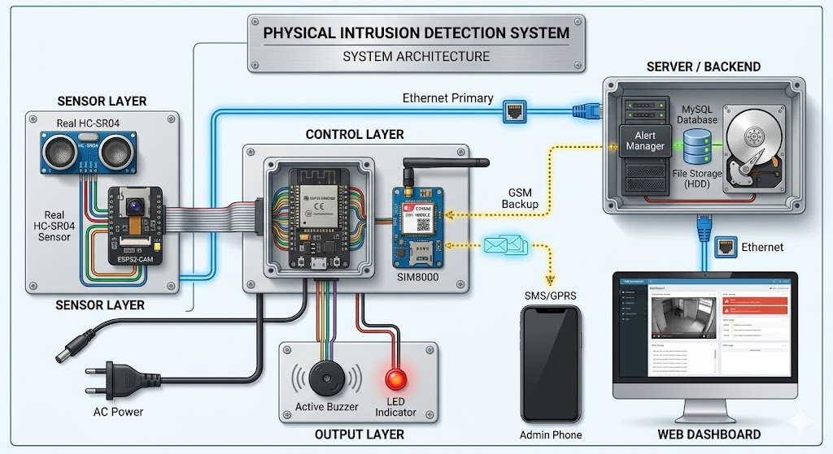
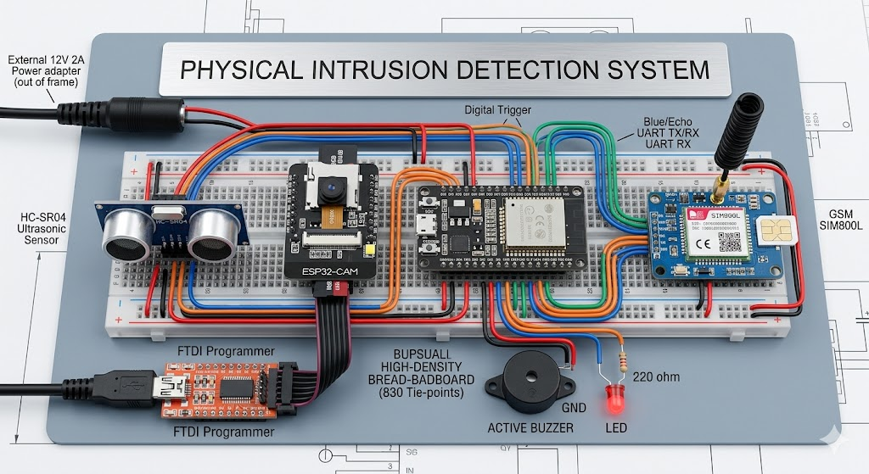
1. Primary ESP32 Node Connections
- HC-SR04 Ultrasonic Sensor:
  - VCC $\rightarrow$ ESP32 5V (or Vin)
  - GND $\rightarrow$ ESP32 GND
  - Trig $\rightarrow$ ESP32 GPIO 12
  - Echo $\rightarrow$ ESP32 GPIO 13
- GSM Module (SIM800L / Similar):
  - VCC $\rightarrow$ External Power Adapter (GSM modules require up to 2A bursts; do not power directly from the ESP32 pin).
  - GND $\rightarrow$ ESP32 GND (Common Ground is mandatory)
  - TX $\rightarrow$ ESP32 GPIO 16 (RX2)
  - RX $\rightarrow$ ESP32 GPIO 17 (TX2)
- Local Alarms:
  - Active Buzzer (+) $\rightarrow$ ESP32 GPIO 25 (with a current limiting resistor if needed, though active buzzers run well on direct logic).
  - Active Buzzer (-) $\rightarrow$ ESP32 GND
  - Red LED (+) $\rightarrow$ 220$\Omega$ Resistor $\rightarrow$ ESP32 GPIO 26
  - Red LED (-) $\rightarrow$ ESP32 GND
- Camera Trigger Interface:
  - Trigger Out $\rightarrow$ ESP32 GPIO 14 $\rightarrow$ ESP32-CAM GPIO 12
2. ESP32-CAM Node Connections (For Photo Capture)
- VCC $\rightarrow$ 5V Power Supply
- GND $\rightarrow$ Common GND
- Trigger In $\rightarrow$ GPIO 12 (Connected to main ESP32 GPIO 14)
3. FTDI Programmer Connections (Only used for flashing code)
- Note: Disconnect the FTDI after programming.
- VCC (5V/3.3V depending on board) $\rightarrow$ ESP32 VCC
- GND $\rightarrow$ ESP32 GND
- TX $\rightarrow$ ESP32 RX (GPIO 3)
- RX $\rightarrow$ ESP32 TX (GPIO 1)
- (For ESP32-CAM: Bridge GPIO 0 to GND to enter flashing mode).
System Architecture Diagram
+-----------------------------+
| 5V/2A Power Adapter |
+-------+-------------+-------+
| |
v v
+-----------------+ +-----+-------+ +-----+--------+
| HC-SR04 Sensor | | ESP32 | | GSM Module |
| | | Main Node | | |
| Trig -> GPIO 12 |<---->| |<->| RX -> GPIO 17|
| Echo -> GPIO 13 | | | | TX -> GPIO 16|
+-----------------+ +------+------+ +--------------+
|
| Trigger (GPIO 14 -> GPIO 12)
v
+-----------------+ +------+------+
| Local Alarms | | ESP32-CAM |
| | | |
| Buzzer->GPIO 25 |<-----+ |----> Saves to MicroSD
| LED ->GPIO 26 | | | (Flash Disk via SPI)
+-----------------+ +-------------+
Project Source Code
The project is split into two programs: one for the Master ESP32 Controller and one for the ESP32-CAM capture peripheral.
1. Main ESP32 Controller Code
C++
// Master Controller Code (ESP32-D0WDQ6)
#include <HardwareSerial.h>

// Pin Definitions
#define TRIG_PIN 12
#define ECHO_PIN 13
#define BUZZER_PIN 25
#define LED_PIN 26
#define CAM_TRIGGER_PIN 14

// Thresholds
const int DISTANCE_THRESHOLD = 50; // Intrusion distance in cm
long duration;
int distance;

// Hardware Serial for GSM (UART2)
HardwareSerial gsmSerial(2);

void sendSMS() {
gsmSerial.println("AT+CMGF=1"); // Set SMS format to text
delay(1000);

// Replace with the destination admin phone number
gsmSerial.println("AT+CMGS=\"+1234567890\"");
delay(1000);

gsmSerial.print("SECURITY ALERT: Physical intrusion detected! Camera has been triggered.");
delay(1000);

gsmSerial.write(26); // ASCII code for Ctrl+Z to send the message
delay(5000);
}

void triggerAlarm() {
// Signal ESP32-CAM to take picture
digitalWrite(CAM_TRIGGER_PIN, HIGH);

// Fire Local Alarms (Buzzer & LED)
for(int i = 0; i < 10; i++) {
digitalWrite(BUZZER_PIN, HIGH);
digitalWrite(LED_PIN, HIGH);
delay(300);
digitalWrite(BUZZER_PIN, LOW);
digitalWrite(LED_PIN, LOW);
delay(300);
}

digitalWrite(CAM_TRIGGER_PIN, LOW);
}

void setup() {
Serial.begin(115200);
gsmSerial.begin(9600, SERIAL_8N1, 16, 17); // RX=16, TX=17

pinMode(TRIG_PIN, OUTPUT);
pinMode(ECHO_PIN, INPUT);
pinMode(BUZZER_PIN, OUTPUT);
pinMode(LED_PIN, OUTPUT);
pinMode(CAM_TRIGGER_PIN, OUTPUT);

digitalWrite(CAM_TRIGGER_PIN, LOW);

Serial.println("Initializing GSM Module...");
delay(3000); // Wait for GSM to attach to network
gsmSerial.println("AT"); // Handshake
delay(1000);
}

void loop() {
// Clear the trigger pin
digitalWrite(TRIG_PIN, LOW);
delayMicroseconds(2);

// Send a 10-microsecond pulse
digitalWrite(TRIG_PIN, HIGH);
delayMicroseconds(10);
digitalWrite(TRIG_PIN, LOW);

// Read echo travel time
duration = pulseIn(ECHO_PIN, HIGH);

// Calculate distance in cm
distance = duration * 0.034 / 2;

if (distance > 0 && distance < DISTANCE_THRESHOLD) {
Serial.print("Intrusion Detected! Distance: ");
Serial.println(distance);

// Execute alert protocols
triggerAlarm();
sendSMS();

delay(10000); // Cooldown to avoid spamming alerts
}

delay(60);
}
2. ESP32-CAM Peripheral Code
This code runs independently on the ESP32-CAM. It waits for its trigger pin to go HIGH, captures an image from the OV2640 sensor, and commits it directly to the onboard Flash Disk (MicroSD card).
C++
// Peripheral Camera Code (ESP32-CAM)
#include "esp_camera.h"
#include "Arduino.h"
#include "FS.h" // File System
#include "SD_MMC.h" // MicroSD Card dependency

#define TRIGGER_PIN 12

// OV2640 Camera Pin Configuration (AI-Thinker model)
#define PWDN_GPIO_NUM 32
#define RESET_GPIO_NUM -1
#define XCLK_GPIO_NUM 0
#define SIOD_GPIO_NUM 26
#define SIOM_GPIO_NUM 27
#define Y9_GPIO_NUM 35
#define Y8_GPIO_NUM 34
#define Y7_GPIO_NUM 39
#define Y6_GPIO_NUM 36
#define Y5_GPIO_NUM 21
#define Y4_GPIO_NUM 19
#define Y3_GPIO_NUM 18
#define Y2_GPIO_NUM 5
#define VSYNC_GPIO_NUM 25
#define HREF_GPIO_NUM 23
#define PCLK_GPIO_NUM 22

int pictureCount = 0;

void configCamera() {
camera_config_t config;
config.ledc_channel = LEDC_CHANNEL_0;
config.ledc_timer = LEDC_TIMER_0;
config.pin_d0 = Y2_GPIO_NUM;
config.pin_d1 = Y3_GPIO_NUM;
config.pin_d2 = Y4_GPIO_NUM;
config.pin_d3 = Y5_GPIO_NUM;
config.pin_d4 = Y6_GPIO_NUM;
config.pin_d5 = Y7_GPIO_NUM;
config.pin_d6 = Y8_GPIO_NUM;
config.pin_d7 = Y9_GPIO_NUM;
config.pin_xclk = XCLK_GPIO_NUM;
config.pin_pclk = PCLK_GPIO_NUM;
config.pin_vsync = VSYNC_GPIO_NUM;
config.pin_href = HREF_GPIO_NUM;
config.pin_sscb_nda = SIOD_GPIO_NUM;
config.pin_sscb_scl = SIOM_GPIO_NUM;
config.pin_pwdn = PWDN_GPIO_NUM;
config.pin_reset = RESET_GPIO_NUM;
config.xclk_freq_hz = 20000000;
config.pixel_format = PIXFORMAT_JPEG;

config.frame_size = FRAMESIZE_VGA; // 640x480 resolution
config.jpeg_quality = 10;
config.fb_count = 1;

esp_err_t err = esp_camera_init(&config);
if (err != ESP_OK) {
Serial.printf("Camera init failed with error 0x%x", err);
return;
}
}

void captureAndSave() {
camera_fb_t * fb = esp_camera_fb_get();
if (!fb) {
Serial.println("Camera capture failed");
return;
}

// Create unique filename
String path = "/intruder_" + String(pictureCount++) + ".jpg";
fs::FS &fs = SD_MMC;

File file = fs.open(path.c_str(), FILE_WRITE);
if(!file){
Serial.println("Failed to open file in writing mode");
} else {
file.write(fb->buf, fb->len);
Serial.printf("Saved file to path: %s\n", path.c_str());
}
file.close();
esp_camera_fb_return(fb);
}

void setup() {
Serial.begin(115200);
pinMode(TRIGGER_PIN, INPUT_PULLDOWN);

configCamera();

if(!SD_MMC.begin()){
Serial.println("SD Card Mount Failed");
return;
}
}

void loop() {
// Check if main ESP32 sent high alert trigger
if (digitalRead(TRIGGER_PIN) == HIGH) {
captureAndSave();
delay(5000); // Lockout window to ensure it saves cleanly
}
delay(100);
}

